Project Scope and Plan (PSP)
General Information:
Project name: Emergency Department Nursing Education: New CMS Guidelines for AMI and Chest Pain Patients
Project Manager Name: Jessie McBurney
Site: Aurora West Allis Medical Center (AWAMC) Location: West Allis, Wisconsin

A. Project Overview:

I currently work in an Emergency Department in a suburb of Milwaukee, WI, where we see a variety of patients. Some of our most critical patients include people suffering from Acute Myocardial Infarctions (AMIs) or most commonly, heart attacks. According to recent data collected, there is a 30% mortality rate associated with patients diagnosed with an AMI. Half of the patients that are having an AMI die prior to arrival to an emergency department and another 5-10% succumbs to death within one year of the diagnosis. For the patients that do survive this terrible event, half of them are re-hospitalized within one year (Zafari, A.M. (2012, Sept 4). The Centers of Medicare and Medicaid Services (CMS) are focused on reducing mortality rates and readmission statistics, thus improving patient care and outcomes.
As of 2013, the Social Security Act will have a new segment titled Hospital Readmissions Reductions Program, which focuses on reducing funding to hospitals with increased readmission rates of patients with a variety of diagnosis’, including that of AMI (The Centers for Medicare and Medicaid Services, 2012 Aug. 1). This program could substantially reduce government funding that my current hospital is dependent on for operations. In part to help reduce AMI readmission rate, improve the quality of care delivered, and ensure continued government funding I would like to compose an Emergency Department education program for all staff members to promote 100% compliance with CMS and my current facility’s standards.
This program will use an interdisciplinary approach which will help provide physicians, nurses, and unlicensed personal education to ensure the best care is provided to patients presenting with AMI symptoms, ensure compliance and guarantee continued funding. The program will be developed with the input of a physician, my clinical nursing supervisor, my manger and myself.
B. Project Goal(s):

To collaborate and create a comprehensive educational power point presentation on caring for an Emergency Department patient presenting with classic and atypical signs and symptoms of Acute Myocardial Infarctions as evidence by staff members participating in the educational program. Each staff member will complete a pre and post exam which will allow for evaluation of knowledge learned regarding current policies and procedures as well as the new CMS standards. The program will be considered a success when and if each staff member receives an 80% or better on the post exam by November 10, 2012. If staff are struggling with the exam, further education and one-on-one discussion will be used to ensure competence and understanding of the information provided.
C. Project Objectives/Deliverables:

- Complete literature review of classic and atypical signs and symptoms of Acute Myocardial Infarctions by September 15, 2012.
- Meet with my interdisciplinary group to discuss key facts to be included in the presentation by September 22, 2012.
- Compose a rough draft of the power point presentation to be delivered to all staff members by October 6, 2012.
- Submit the rough draft of the power point presentation to the interdisciplinary group for approval and/or changes by October 8, 2012.
- Submit final power point presentation to the interdisciplinary group for approval by October 20, 2012.
- Present the finalized power point presentation of Emergency Department Education on the Acute Myocardial Infarction Patient to all staff members at huddles and via email starting November 7, 2012.
- Grade each pre and post test immediately after delivery in order to evaluate if any staff member needs additional education and/or instruction.
- Evaluate the staff member’s knowledge of caring for the Acute Myocardial Infarction patient after completion of a pre and post assessment after presentation.
- Reinforce the education presented by providing a quick-reference on the central nursing bulletin board in the Emergency Department by November 10, 2012.
D. Comprehensive List of Project Requirements/Activities/Tasks:
- Complete literature review of classic and atypical signs and symptoms of Acute Myocardial Infarctions by September 15, 2012 – 15 hours, total.
  - Identify key search words by September 10 – 2 hour.
  - Complete literature review by September 10 – 8 hours.
  - Compose a summary of information with sources by September 10 – 5 hours.
- Meet with my interdisciplinary group to discuss key facts to be included in the presentation by September 22, 2012 – 4 hours, total.
  - Schedule a date in which all and/or individual meetings can be arranged with fellow group members by September 15 – 1 hour.
- Compose a rough draft of the power point presentation to be delivered to all staff members by October 6, 2012 – 15 hours, total.
  - Discuss with group members information to be included in the power point by September 22 – 3 hours.
  - Discuss different options for presenting to individuals with different preferred methods of learning by September 22 – 1 hour.
  - Identify key graphics to be included in power point to assist with learning by October 5 – 3 hours
  - Create rough draft of power point by October 6, 2012 – 8 hours.
- Submit the rough draft of the power point presentation to the interdisciplinary group for approval and/or changes by October 8, 2012 – 7 hours, total.
  - Have two peers proof read power point for discrepancies and/or errors by October 6 – 2 hours (1 hour per peer).
  - Correct and finalize power point by October 7 – 4 hours.
  - Determine preference of reviewing power point for each group member by October 15 – 1 hour.
- Submit final power point presentation to the interdisciplinary group for approval by October 20, 2012 – 16 hours, total.
  - Submit power point for approval to each member by individual preference by October 8 – 8 hours (2 hours each group member).
  - Receive critiques from members by October 13.
  - Review critiques and make any necessary changes by October 19 – 8 hours (2 hours each critique)
- Present the finalized power point presentation of Emergency Department Education on the Acute Myocardial Infarction Patient to all staff members at huddles and via email starting November 7, 2012 – 14 hours, total.
  - Receive final critiques from peers by October 27.
  - Review final critiques by November 1 – 4 hours.
  - Finalize power point by November 3 – 6 hours.
  - Print and prepare all presentation material by November 6 – 4 hours.
- Grade each pre and posttest immediately after delivery in order to evaluate if any staff member needs additional education and/or instruction – 13 hours, 30 minutes, total.
  - Collect the pretest and calculate grade immediately after each exam – 5 hours (estimated 5 presentations).
  - After each presentation, evaluate posttests; identify any staff member that did not receive an 80% on the post exam – 30 minutes each = 2 hours, 30 minutes.
  - Discuss with each staff member that does not receive an 80% any questions that they may have; identify the areas in which they did not do well and go over the correct answer with further education immediately after each exam – 6 hours (varies by staff member performance).
- Evaluate the staff member’s knowledge of caring for the Acute Myocardial Infarction patient after completion of a pre and post assessment after presentation – 5 hours, total.
  - Develop pre and posttests by November 3 – 3 hours.
  - Distribute evaluations in email at time of sending, distribute evaluations in huddles pre and post presentation – 2 hours.
- Reinforce the education presented by providing a quick-reference on the central nursing bulletin board in the Emergency Department by November 10, 2012 – 5 hours, total.
  - Collect all supplies necessary by November 3 – 2 hours.
  - Create poster board by November 6 – 3 hours.
E. Timeline:
See above section, D. Comprehensive List of Project Requirements/Activities/Tasks, for an estimated dated of completion for each task.
F. Assumptions & Constraints:
Assumptions:
- All members will be available and flexible for meetings and input.
- Communication will be upheld by all members, in a constructive manner.
- Timeline is achievable, with flexibility of dates.
Constraints
- Availability of group members to conduct meetings and provide input.
- Variable reception from fellow staff members and compliance with pre and post examinations.
G. Success Criteria:
This project will help enhance the Emergency Department of Aurora West Allis Medical Center’s (AWAMC) competency of treating the patient that presents with typical and atypical signs and symptoms of an Acute Myocardial Infarction. This project will also help safeguard that each patient is receiving the best care as well as the most current evidence based treatments.
It will help promote 100% efficiency of meeting all CMS guidelines as well as AWAMC standards and policies and procedures. This project will also help ensure reimbursement and funding continues. Faster, more efficient treatment will be provided to patients that present with symptoms of AMI. According to Meils, Kaleta, and Mueller (2002), “Multiple randomized clinical trials have demonstrated that reducing delays in the initiation of reperfusion therapy significantly reduces morbidity and mortality”. Increased knowledge will lead to better recognition, more proficient treatment and increased rates of survival of such a disastrous cardiac event.
The first indicator of success is when each staff member passes the posttest with an 80% or better. The person(s) that do not meet this expectation will then have follow up instruction and education on areas of question. Long-term success can be measured by the department meeting all standards of care, as well as the CMS guidelines. The long-term success will not be able to be identified until the data is reviewed and collected by the quality department of AWAMC, this sometimes can take several months. From the presentations, I would anticipate that the data for November/December would not be reviewed until January/February. Once this is done, my CNS will inform me of any fallouts or benchmarks that need improving on, in which I will then reinforce this information with hope in ensuring 100% compliance from then on.
H. Signatures: *Please see Appendix A for signatures.
Project Manager:

Nurse Manager:

Phone: 1-414-328-6154 Email: Kathleen.Koehler@aurora.org

Appendix A.
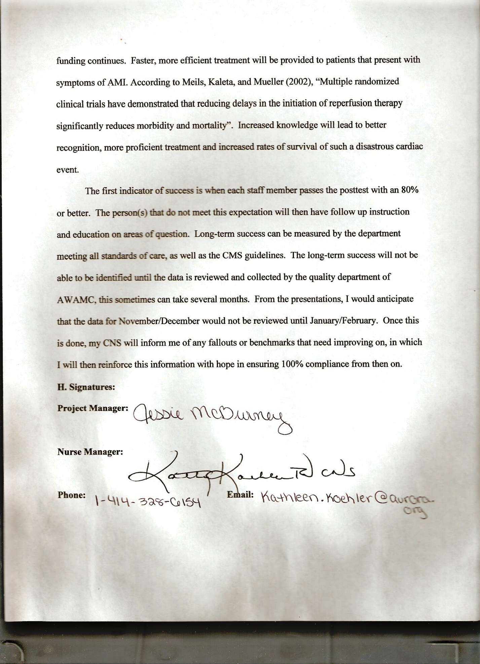
References
Meils, C.M, Kaleta, K.A. & Mueller, C.L. (2002, October). Treatment of the patient with acute myocardial infarction: Reducing time delays. Journal of Nursing Care Quality.
The Centers for Medicare and Medicaid Services. (2012, Aug. 1). Readmissions reduction program. Retrieved from http://cms.gov/Medicare/Medicare-Fee-for-Service-Payment/AcuteInpatientPPS/Readmissions-Reduction-Program.html/
Zafari, A.M. (2012, Sep. 4). Myocardial infarction: Prognosis. Retrieved from http://emedicine.medscape.com/article/155919-overview#aw2aab6b2b6aa

